Name : Dev Adnani  
SID : 202212012

Subject : Systems Programming

Assignment : 4

**202212012_Lab4_1_pow.c**

#include <stdio.h>

float powx(float base,int to_pow)

{

float pow=1;

for(int i=1;i<=to_pow;i++)

{

pow*=base;

}

return pow;

}

**202212012_Lab4_1_fact.c**

#include <stdio.h>

int fact(int num)

{

int fac = 1;

for (int i = 1; i <= num; i++)

{

fac *= i;

}

return fac;

}

**202212012_Lab4_1.h**

**i**nt fact(int num);

float powx(float base,int to_pow);

**202212012_Lab4_1.c**

#include <stdio.h>

#include "202212012_Lab4.h"

int main()

{

int x, sign = 1;

float p, sinx = 0;

printf("Enter value of sin(x) : ");

scanf("%d", &x);

p = x * (3.14 / 180);

for (int i = 1; i <= 20; i += 2)

{

sinx = sinx + (sign * (float)powx(p, i) / fact(i));

sign *= -1;

}

printf("Sin(%d) = %f\n", x, sinx);

return 0;

}

Problem 1: Create executable from multiple source files and using own header file

• Create a separate sources files to implement following functions: o

Write c program StudentID_Lab4_1_fact.c to implement factorial of a number function with signature “int myfact(int). o

Write c program StudentID_Lab4_1_pow.c to implement power function with profile “int mypow(int, int)”.

• Create StudentID_Lab4_1_myheader.h to declare the function signatures

• Create StudentID_Lab4_1_main.c to call these function from main() to calculate sin(x) as given by formula • sin(𝑥) = 𝑥 − 𝑥 3 3! + 𝑥 5 5! − …

• Compile each of the source files using –c option of gcc to build object files

• Build an executable using all the object files

• Run the executable and capture the output

Screenshot :

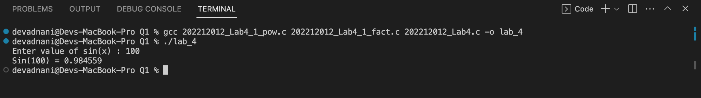

Problem 2: Create static library using c source files from Problem1

Create a static library with functions object files (i.e.   
StudentID_Lab4_1_fact.o, StudentID_Lab4_1_pow.o etc)   
Create an executable without using –l option and run it   
Create an executable with –l option and run it   
Run the executable generated using static library and captures the output.

Screenshot :

Q2 - A

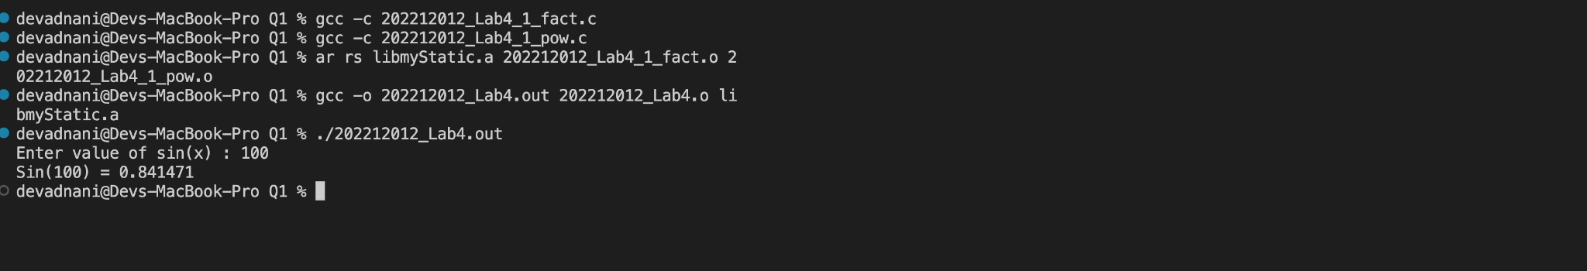

Q2 - B

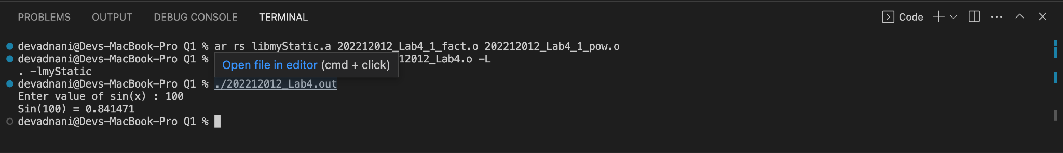

Problem 3: Create shared/dynamic library using c source files from problem 1

* Create a shared library with functions object files (i.e. StudentID_Lab4_1_fact.o, StudentID_Lab4_1_pow.o etc) which are  
  recompiled using “Position Independent Code” option
* Set up search path for library file in LD_LIBRARY_PATH
* Create an executable with and without –l option
* Create your own configuration file in /etc/ld.so.conf.d/ with folder where your library file is to be used with -l option (without -L option)
* Run the executable generated using dynamic library and capture the  
  Output.

Screenshot :

3-A

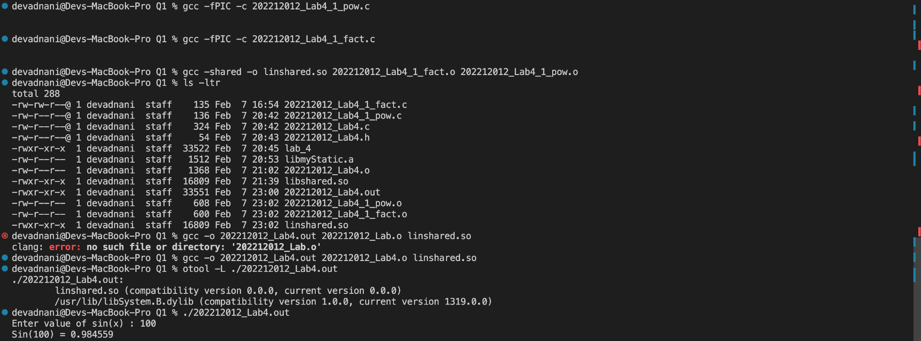

3-B

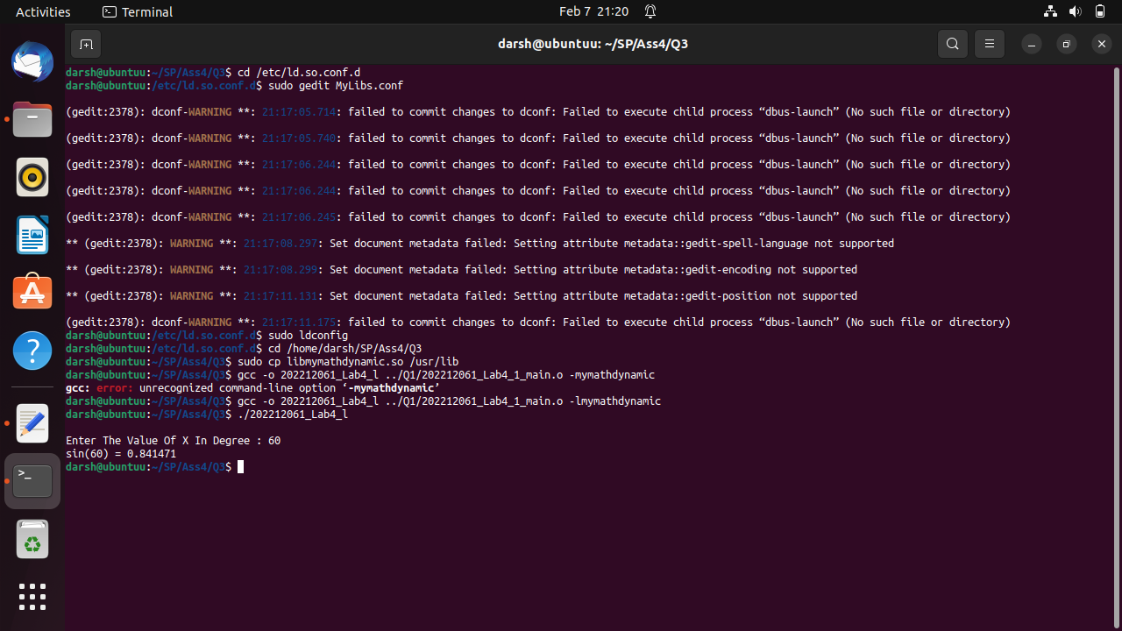

Problem 4: Create makefile for all the steps from Problem 1, 2 and 3 and run them instead of individual commands.

MakeFile Code :

CC=gcc

CFLAGS=-I$(IDIR)

IDIR =../include

ODIR=obj

LDIR =../lib

LIBS=-lm

BDIR=../bin

_DEPS = 202212012_Lab4_1_myheader.h

DEPS = $(patsubst %,$(IDIR)/%,$(_DEPS))

_LIBOBJ = 202212012_Lab4_1_fact.o 202212012_Lab4_1_pow.o

LIBOBJ = $(patsubst %,$(ODIR)/%,$(_LIBOBJ))

_LIBOBJfPIC = 202212012_Lab4_1_fact_fPIC.o 202212012_Lab4_1_pow_fPIC.o

LIBOBJfPIC = $(patsubst %,$(ODIR)/%,$(_LIBOBJfPIC))

LIBSRC = 202212012_Lab4_1_fact.c 202212012_Lab4_1_pow.c

_APPOBJ = 202212012_Lab4_1_main.o

APPOBJ = $(patsubst %,$(ODIR)/%,$(_APPOBJ))

$(ODIR)/202212012_Lab4_1_fact_fPIC.o: 202212012_Lab4_1_fact.c

$(CC) -c -fPIC -o $@ $< $(CFLAGS)

$(ODIR)/202212012_Lab4_1_pow_fPIC.o: 202212012_Lab4_1_pow.c

$(CC) -c -fPIC -o $@ $< $(CFLAGS)

$(ODIR)/202212012_Lab4_1_fact.o: 202212012_Lab4_1_fact.c

$(CC) -c -o $@ $< $(CFLAGS)

$(ODIR)/202212012_Lab4_1_pow.o: 202212012_Lab4_1_pow.c

$(CC) -c -o $@ $< $(CFLAGS)

$(LDIR)/libmymathdynamic.so:$(LIBOBJfPIC)

$(CC) -shared -o $@ $^

LDLIBPATH:

export LD_LIBRARY_PATH=$$LD_LIBRARY_PATH:$(LDIR)

$(LDIR)/libmymath.a:$(LIBOBJ)

ar rs $@ $^

$(APPOBJ): 202212012_Lab4_1_main.c $(DEPS)

$(CC) -c -o $@ $< $(CFLAGS)

$(BDIR)/202212012_Lab4_2.out: $(APPOBJ)

$(CC) -o $@ $^ $(CFLAGS) $(LDIR)/libmymath.a

$(BDIR)/202212012_Lab4_2_l.out: $(APPOBJ)

$(CC) -o $@ $^ $(CFLAGS) -L$(LDIR)/ -lmymath

$(BDIR)/202212012_Lab4_3.out: $(APPOBJ)

$(CC) -o $@ $^ $(CFLAGS) $(LDIR)/libmymathdynamic.so

$(BDIR)/202212012_Lab4_l.out: $(APPOBJ)

$(CC) -o $@ $^ $(CFLAGS) -L$(LDIR)/ -lmymathdynamic

$(BDIR)/file1.out: $(LIBOBJ) $(APPOBJ)

$(CC) -o $@ $^ $(CFLAGS)

.PHONY: clean

clean:

rm -f $(ODIR)/*.o *~ core $(INCDIR)/*~

rm -f $(BDIR)/*.out $(LDIR)/*

.PHONY: all

all: LDLIBPATH $(BDIR)/file1.out $(LDIR)/libmymath.a $(LDIR)/libmymathdynamic.so $(BDIR)/202212012_Lab4_2.out $(BDIR)/202212012_Lab4_2_l.out $(BDIR)/202212012_Lab4_3.out $(BDIR)/202212012_Lab4_l.out

Screenshot :

